|  |  |
| --- | --- |
| **WC Logo.emf** | **Staff Report to the Weber County Commission**  *Weber County Planning Division* |
|  | |

****Synopsis****

****Application Information****

**Application Request:** Ordinance to vacate a portion of 10000 East St., located at approximately 394 S 10000 E, Huntsville, UT, 84317.

**Agenda Date: Tuesday, May 23, 2023**

**Applicant:** Mark & Stephanie Perkes and David & Barbara Benstog (owners)

**File Number:** VAC 2022-01

****Property Information****

**Approximate Address:** 394 S 10000 E, Huntsville, UT, 84317

**Zoning:** Forest Valley (FV-3) Zone

**Existing Land Use:** Residential

**Proposed Land Use:** Residential

**Parcel ID:** N/A

**Township, Range, Section:** T6N, R2E, Section 15 SE

****Staff Information****

**Report Presenter:** Tammy Aydelotte

taydelotte@webercountyutah.gov

801-399-8794

**Report Reviewer:** SB

Background

The applicant is requesting to vacate a portion of a public right of way (10000 East St.). If the portion of 10000 East Street is vacated, the applicants will have more buildable area within the boundaries of lots 10 and 11 in South Fork Ranchettes Subdivision (parcel numbers 210460007 and 210460006). The County Engineer’s office and the County Surveyor’s office have reviewed the vacation request and have conditionally approved of the project.

Under state codes (17-27a-609.5), the County Commission, as the legislative body, may adopt an ordinance granting a petition to vacate some or all of a public street or county utility easement if the legislative body finds that:

(a) good cause exists for the vacation; and

(b) neither the public interest nor any person will be materially injured by the vacation.

Conformance to the General Plan

This vacation request is not anticipated to have an impact on the Ogden Valley General Plan. If the vacation is approved, the applicant will have more buildable area added to each lot.

Staff Recommendation

Staff recommends approval of the proposed ordinance, vacating the portion of 10000 East St. shown on the ordinance as Exhibit A, and illustrated on a vacation plat in Exhibit B.

Exhibits

1. Vacation Ordinance
2. Vacation Plat

Location map

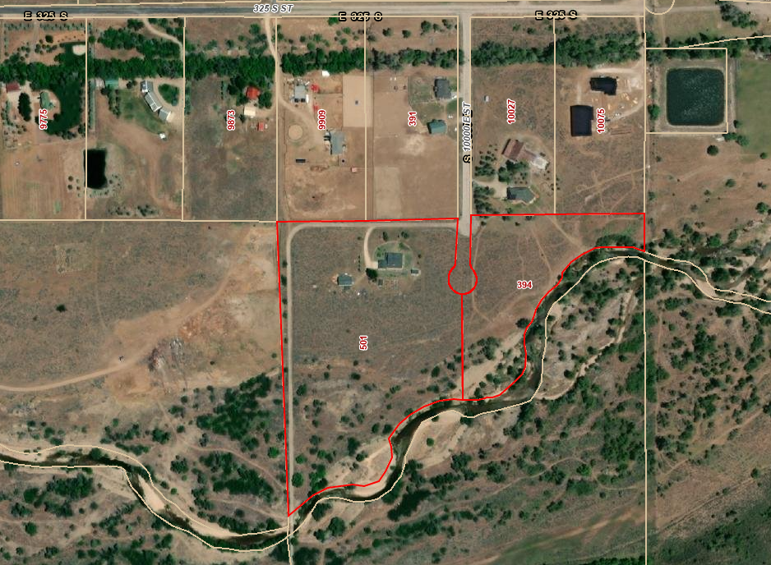

Exhibit A – Vacation Ordinance

**see following page.**

**Ordinance No.**

**An ordinance of Weber County vacating**

**a PORTION OF A PUBLIC RIGHT-OF-WAY ALONG oLD sNOWBASIN rD**

**WHEREAS,** Weber County has filed a petition to vacate a portion of 10000 East Street, that portion being located at approximately 400 S 10000 E, as described in Exhibit A of this ordinance; and

**WHEREAS,** after providing proper public notice, a public hearing was held before the Weber County Commission on May 23, 2023, regarding the vacation of the portion of public right-of-way; and

**WHEREAS,** Weber County’s Engineering Department has been notified and has provided written approval of the vacation of the portion of the public right-of-way; and

**WHEREAS,** the Commission finds that good cause exists to vacate the portion of public right-of-way, and that it will not substantially affect the Ogden Valley General Plan, and that neither the public interest nor any person will be materially injured;

**NOW THEREFORE,** the Board of County Commissioners of Weber County vacates the portion of public right-of-way, as described in Exhibit A of this ordinance.

Adopted and ordered published this day of , 2023.

Weber County Commission

By_________________________________

Gage Froerer, Chair

Commissioner Froerer Voted

Commissioner Harvey Voted___________

Commissioner Bolos Voted

ATTEST:

_________________________________

Ricky Hatch, CPA

Weber County Clerk

Exhibit A

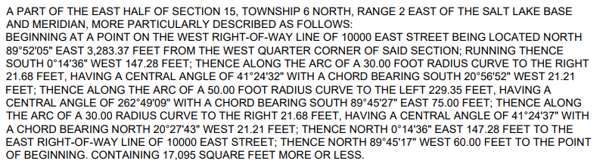

Exhibit B – Vacation Plat

